Lacemaking Tour
to the beauty spots on Europe’s exquisite face
Venice, Slovenia & Croatia May 2019

If you have never been to or even heard of Slovenia, then you will find this small country sandwiched between Austria and Italy on one side, and sharing borders with Hungary to the east and Croatia in the south. It is small, beautiful, and full of surprises. After the end of WWII, Slovenia became part of the republic of Yugoslavia, but gained its independence in 1991 and is now part of the European Union.

Slovenia is smaller than Tasmania, but quite diverse in its geography. The north of the country is quite mountainous, being part of the Austrian Alps with magnificent alpine peaks, glacial valleys, and lakes, whilst some of its south western terrain features karst country, a vast limestone plateau which is riddled with more than 6000 caves, subterranean rivers and sinkholes. Slovenia touches the Adriatic Sea for just 47 kilometres in the west, but it boasts many rivers, streams, and mineral springs throughout its land. The Pannonian Basin which is located on the eastern side of Slovenia, has rolling plains and hills which are lined with vineyards and olive groves, as well as being heavily wooded; its primeval forests cover more than half of its lands, making this country an ideal green place to view natural beauty and species at their best. Its spas and mineral springs are found in all of these areas in many health resorts.

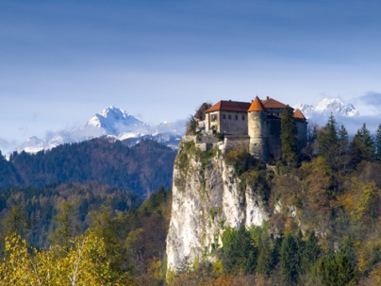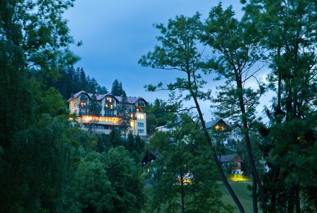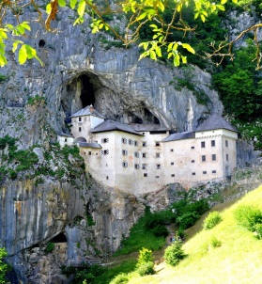

Ljubljana the capital city is found in the centre of Slovenia and this means that most areas of the country are located within two hours travel from the capital, making it possible for tourists to visit a number of different areas in the one day. Places you will see on this wonderful tour include the ancient medieval city of Piran perched on the shores of the Mediterranean opposite Venice in Italy. Postojna Caves and Predjama Castle are located in karst country; the Lipica stud farm is one of the oldest stud farms in the world and the birthplace of the Lipizzaner breed of horses; then further north Vintgar Gorge, the town of Bled with its exquisite lake where you can take a ‘pletna boat ride’ to the island and Bled Castle situated high on a rocky outcrop. Lake Bled is exceptionally beautiful in all seasons.

Close by there is the Bohinj Lake and cable car ride up to Mount Vogel; and the alpine dairy museum at Bohinj. Another must see destination is the city of Radovljica, before heading to Ljubljana where boat and funicular rides reveal more of this quaint city guarded by its medieval castle overlooking the baroque churches, Ljubljanica River and parks that make up this place with many attractions within easy walking distance. The Old Town area with its cobbled streets combines well with the cosmopolitan bars and restaurants which are a feature of this city.
Moving on to the east of Slovenia, are the second largest city (Maribor) and the oldest Slovenian town of Ptuj located in the Pannonian Basin region. This area is known for its wine and food production, and gently rolling hills and valleys. These are the attractions which tourists can visit and see in this pint sized country.

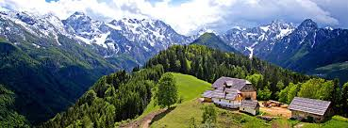

An optional extension to this tour will focus on scenic places in Croatia, such as a short tour of the beautiful coastal city of Rovinj, and then on to Plitvice Lakes a UNESCO World Heritage site, where time will be spent either hiking or going for a train ride or boating as the beautiful natural scenery of the lakes is explored. The historic old city of Split will be visited where the Roman emperor Diocletian built his palace with room for a military garrison. Not far off the Dalmatian coast is the small island of Hvar, where the economy relies on the cultivation of grapes for wine, and lavender for aromatic oils used in perfumes and soaps. It also heavily relies on the tourist trade. Since the 1600s Benedictine nuns have perfected the art of lacemaking by weaving the fibres of dried agave leaves in order to produce a fibre suitable for making lace which can be seen in the Hvar monastery.

Another place further south of Hvar is the stunning small island of Korcula, where it is argued that Marco Polo was born. Its medieval squares, churches and buildings make this one of Croatia’s most treasured islands. Across the water can be seen the town of Orebic, after a short ferry ride, giving spectacular view of Korcula.

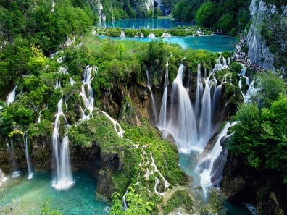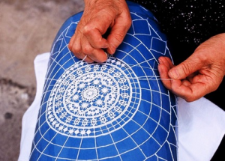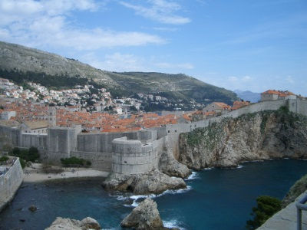

On to magnificent Dubrovnik which has been called The Pearl of the Adriatic. A walk around the ancient stout walls that protect the old city affords a spectacular view from the top of the island as your view is across the medieval city and the azure sea to Lokrum island. Alternatively use the cable car to reach the top of Mount Srdj where even more spectacular views can be seen. A small trip across the border into Montenegro to Kotor Bay, another UNESCO world heritage site. Words can sometimes fail when trying to describe the spectacular water and mountain views in this area of the Balkans. Just believe me, you won’t be disappointed!

However, we haven’t even discussed the Slovenian lace which is the special interest focus of this tour!

Firstly, we will visit an island named Burano, which is located off the coast of Venice in Italy. This day trip will focus on the beautiful handmade needle lace which is produced by the fishermen’s wives who live on this island. Their lace work is spectacular! You will want to take a piece home with you!

Most of the lace that we will view in Slovenia will be in a small country town named Idrija, made famous for its bobbin lace and the mercury mine which is now closed but open for visitors. The women of this town brought their lace making skills with them around 300 years ago from Germany and Czechoslovakia when their husbands moved to Idrija to work in the mine. The lace made here was fairly basic and rough in design and execution, being mainly produced for the homes in Idrija, and those skills have been passed down to family members who today produce a now famous and beautiful tape lace known worldwide as Idrija lace. This tour will visit historical and lace focused places in Idrija over a number of days, as well as having a 3 hour workshop where we will actually make some of that lace. Other small lace making towns will also be visited, and a viewing of their museum lace exhibits will take place. Hopefully we will be able to purchase more lace in shops in Idrija! If you love lace and making lace, as well as spectacular scenery, then you should come on this tour!

At this stage we are only seeking “Expressions of Interest” to see whether we have enough people to join this lovely tour. The tour is limited to a maximum 20 participants but will operate on a minimum of 16 participants. The anticipated travel dates will be mid to end May 2019 but the actual dates and costs will be confirmed in the next 2 months. To register your interest in joining this tour or to request further information without any obligation whatsoever simply call Stephanie Savage at Impulse Travel on 1-300-55-75-01 or send an email to stephanie@impulsetravel.com.au.

